Power BI:

Introduction to Power BI
Power BI is a business analytics tool developed by Microsoft that enables users to visualize data, share insights, and make data-driven decisions. It provides interactive dashboards and reports that connect to a wide range of data sources, allowing organizations to transform raw data into meaningful insights.
Key Features
- Data Connectivity: Connects to multiple sources like Excel, SQL Server, Azure, APIs, and cloud services.
- Data Transformation: Built-in Power Query for cleaning and shaping data.
- Interactive Visualizations: Wide range of charts, maps, and custom visuals.
- Real-Time Dashboards: Monitor live data and KPIs.
- Integration: Works seamlessly with Microsoft tools like Excel, Teams, and Azure.
- AI Capabilities: Natural language queries, predictive analytics, and machine learning integration.
Benefits
- User-Friendly: Drag-and-drop interface for creating reports.
- Scalable: Suitable for individuals, teams, and enterprises.
- Secure Sharing: Role-based access and governance.
- Cross-Platform: Available on desktop, web, and mobile.

1. No. of Treatments According to Ages

Chart Type: Area chart.
X-Axis: Age (ranging from 0 to 100).
Y-Axis: Number of Treatments.
Insights:
Treatments are relatively high for ages between 0–20, with fluctuations around 100–200 treatments.
There is a sharp increase from age 40 onwards, peaking between 55–65 years, where treatments exceed 400 (highest point around 467).
After age 70, treatments decline significantly, dropping below 100 for ages above 90.
Interpretation: Middle-aged and senior individuals (40–70) receive the highest number of treatments, indicating higher healthcare needs in these age groups.
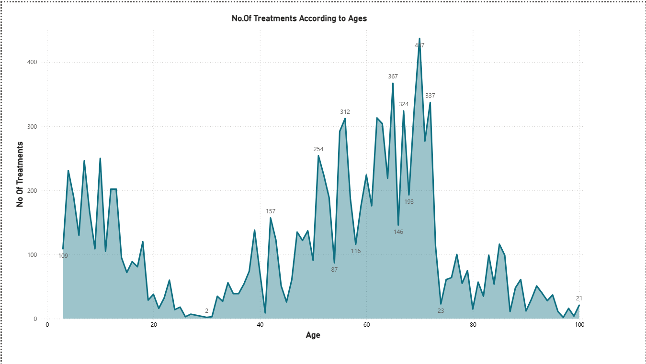

2. Number of Treatments Across Diseases

Chart Type: Clustered bar chart.
X-Axis: Diseases (Psoriasis, Asthma).
Y-Axis: Number of Treatments.
Legend: Sections for different years and top categories (2021 top1, top2, top3; 2022 top1, top2, top3).
Insights:
Both Psoriasis and Asthma have similar treatment counts across categories.
Psoriasis shows a spike in 2022 top1 (around 4 treatments), while others hover around 2–3.
Interpretation: Psoriasis treatments increased in 2022 compared to Asthma, suggesting a trend or priority shift.
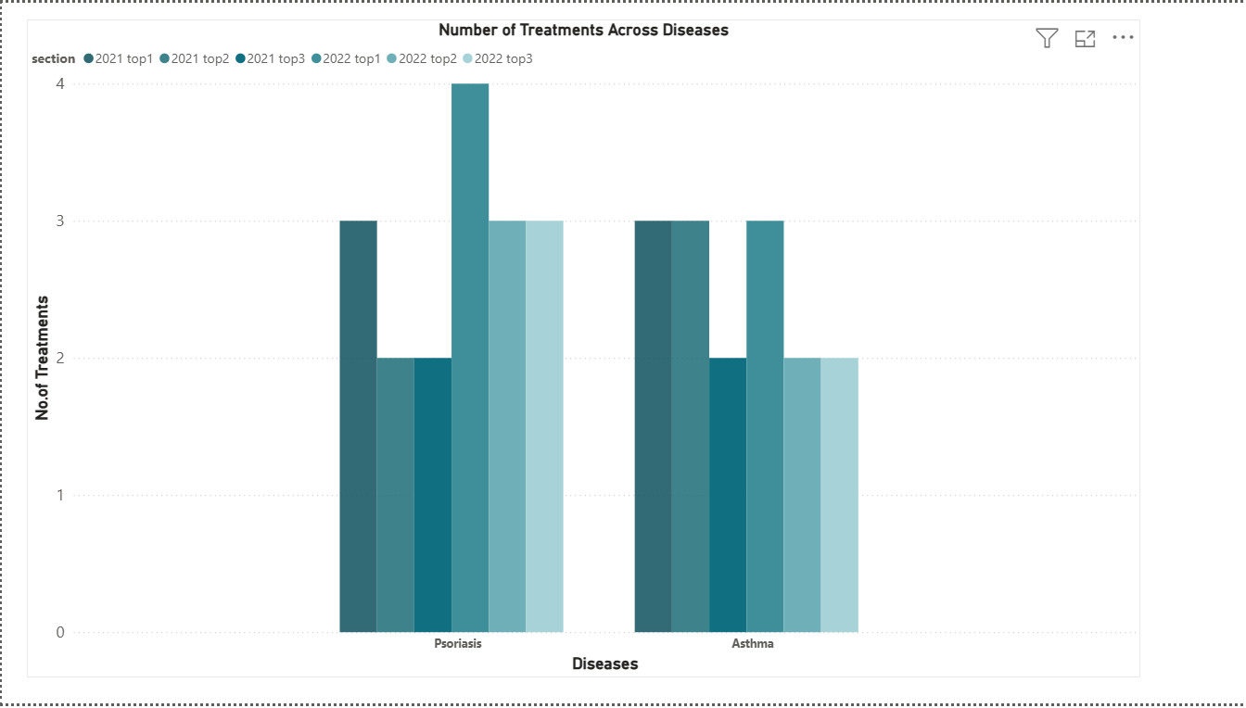

3. Total Treatments and Uninsured Treatments by State

Chart Type: Horizontal bar chart.
X-Axis: Number of Treatments.
Y-Axis: States (CA, AL, TN, OK, FL, DC, CO, GA, CT, MD, AR, VT, AZ, MA, KY, AK).
Insights:
California (CA) leads with over 1000 treatments, followed by AL and TN (~800).
Other states range between 400–700 treatments.
The chart compares total treatments vs uninsured treatments, showing uninsured treatments are a smaller proportion.

Interpretation: CA has the highest healthcare activity, and uninsured treatments are significant but not dominant.
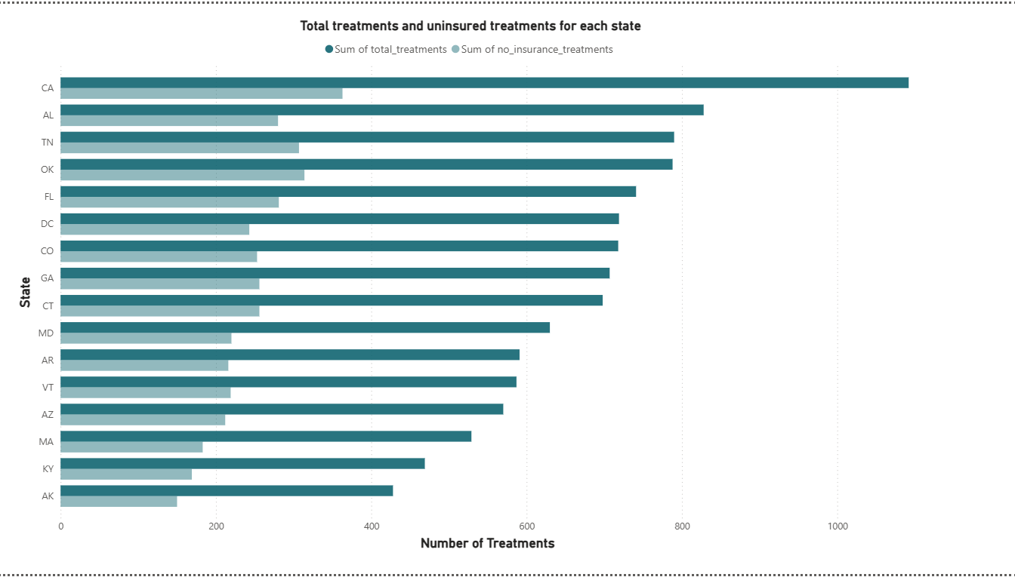

4. Sum of Max Price by Cost Category
Chart Type:
Bar chart
X-Axis: Cost Category (costly, moderate, affordable).
Y-Axis: Sum of Max Price.
Insights:
Costly treatments dominate with over 10M in max price.
Moderate treatments are around 1–2M, and affordable treatments are below 1M.
Interpretation: High-cost treatments contribute the most to overall expenditure, highlighting cost concentration.
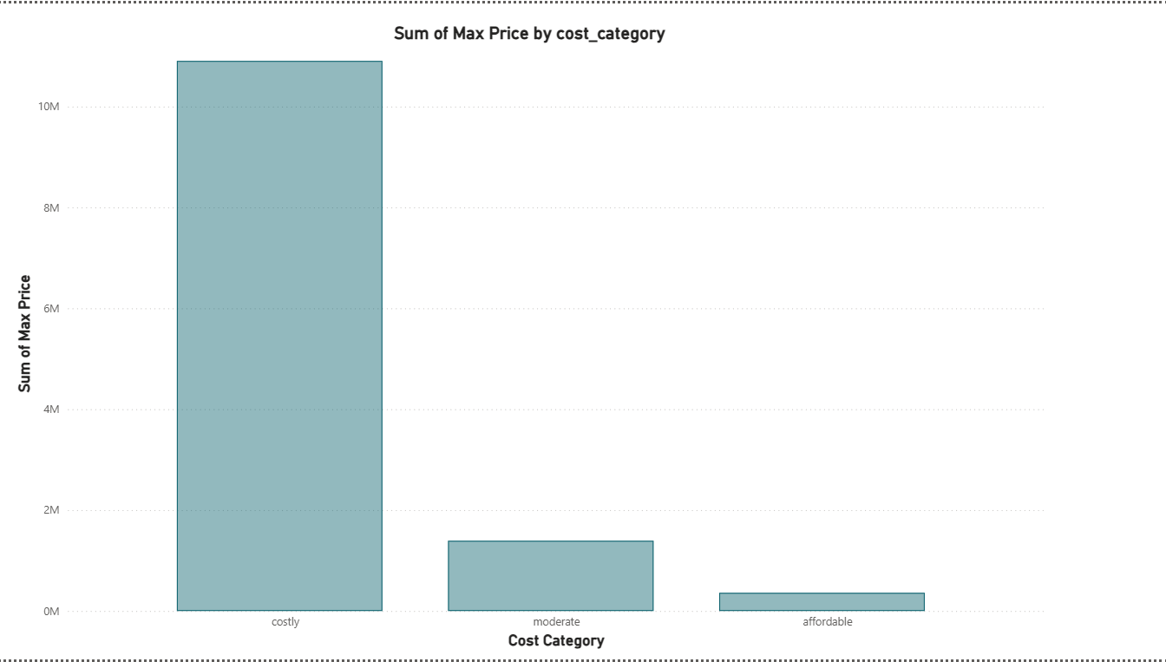

5. Sum of Households by Disease Name

Chart Type:
Area chart.
X-Axis: Disease Names (multiple conditions listed).
Y-Axis: Households (ranging from 30 to 60).
Insights:
Highest household count (~60) for Cancer diseases, followed by Stroke and related conditions.
Gradual decline across other diseases, with the lowest around 30 households.
Interpretation: Cancer and stroke-related conditions affect the largest number of households, indicating priority areas for healthcare planning.
Overall Dashboard Description
This Power BI dashboard provides a comprehensive view of healthcare treatments and costs, segmented by:
Age distribution (peak treatments in middle-aged and senior groups).
Disease-specific trends (Psoriasis vs Asthma).
Geographic distribution (state-wise treatments and uninsured cases).
Cost analysis (costly treatments dominate expenditure).
Household impact by disease (Cancer and stroke most prevalent).
